Angle Measurements by Camera – Short Report X-Cali

Measurement: Burak SEZGİN, Data extraction: Burak SEZGİN

Before the integration of the angle measurement code and camera on the vehicle, they are tested. A4 Tech PK-900H model of webcam is used for this test to measure the angle of the plank. The test specifications are provided below.

|  |  |
| --- | --- |
| Environment | : Living Room, luminous |
| Driver | : RaspberryPi3 |
| Camera | : A4 Tech PK-900H |
| Temperature | : 24℃  N |

Measurement Tool: IC Measure (On-Screen Measurement Software)

Measurement Method (Angle):

First, some arbitrary angles are adjusted for plank and it is photographed. Then, with the help of the angle measurement code, plank’s angle on photo is measured. Furthermore, real angle of the plank is measured by a software (IC Measure).

Measurement Method (FPS):

First, the number of frames of the video is set to specific values such as 100, 200 … up to 1000 frames. Then, for these number of frames, FPS is calculated as follows: a stopwatch code is utilized which measures time difference between the first frame and the last one. And to find FPS value, frame number is divided into that time difference.

The following graphs are obtained using MATLAB.

|  |  |
| --- | --- |
| Real Angle (Degrees) | Measured Angle by Camera (Degrees) |
| -70,5 | -70 |
| -56,5 | -56 |
| -34 | -36 |
| -15,5 | -17 |
| 1 | 0 |
| 16,5 | 18 |
| 35 | 36 |
| 53,5 | 54 |
| 72,5 | 72 |
| 83,5 | 82 |

Table 1: Measurement results of angle by camera (in a range between -90 and 90 degrees)

|  |  |  |
| --- | --- | --- |
|  | When planck is not detected | When planck is detected |
| Number of frames | Measured FPS | Measured FPS |
| 100 | 22,42 | 21,59 |
| 200 | 21,62 | 21,34 |
| 300 | 21,94 | 21,95 |
| 400 | 22,42 | 21,41 |
| 500 | 22,29 | 21,68 |
| 600 | 21,93 | 21,58 |
| 700 | 22,09 | 21,61 |
| 800 | 22,14 | 21,34 |
| 900 | 22,14 | 21,86 |
| 1000 | 22,28 | 21,62 |

Table 2: Measurement results of FPS for all circumstances (For when plank is detected and not detected)

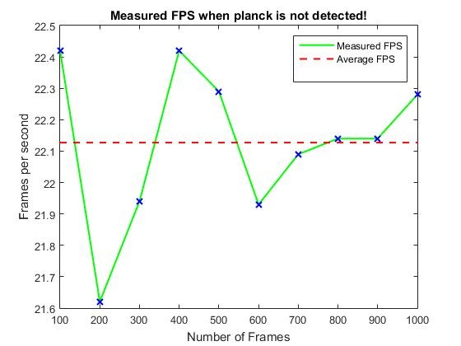

Figure 1: Measured FPS When Planck is not Detected

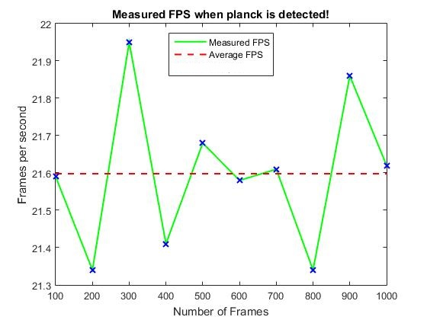

Figure 2: Measured FPS When Planck is Detected

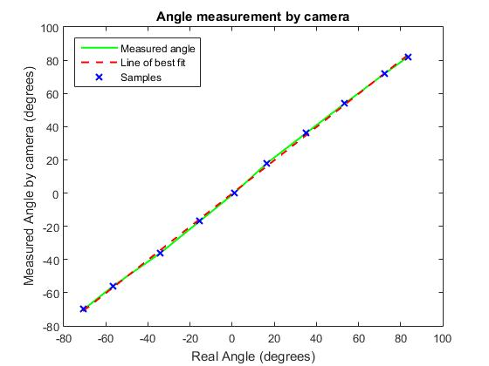

Figure 3: Angle Measurement Results of Camera

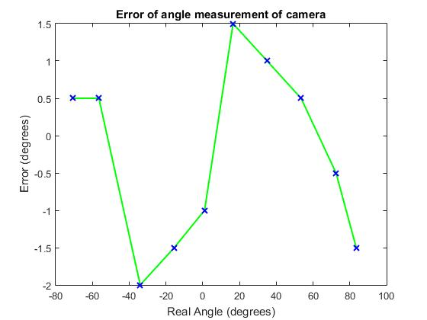

Figure 4: Error of Angle Measurement of Camera